A Mixed Bag
Level 1: Grabbing just 1 commit
For this problem, the pre-requisites are knowing the basic git commands such as commit, branch ,merge ,rebase, cherry-pick etc.
Suppose there is a bug in your development and you track it down and fix it but now you have to get a particular branch to master branch. It’s like you have to copy only one commit over. It can be done with the help of moving around section commands, Basically it is an application of those commands.
This is the initial case:
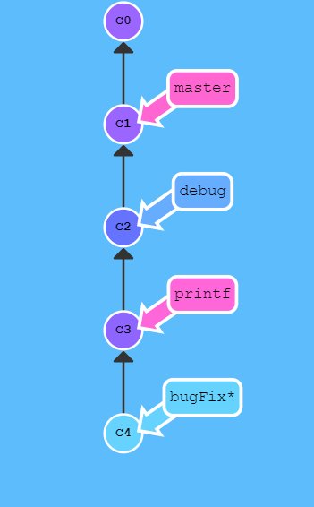
Your Goal is to get bugfix to master branch.
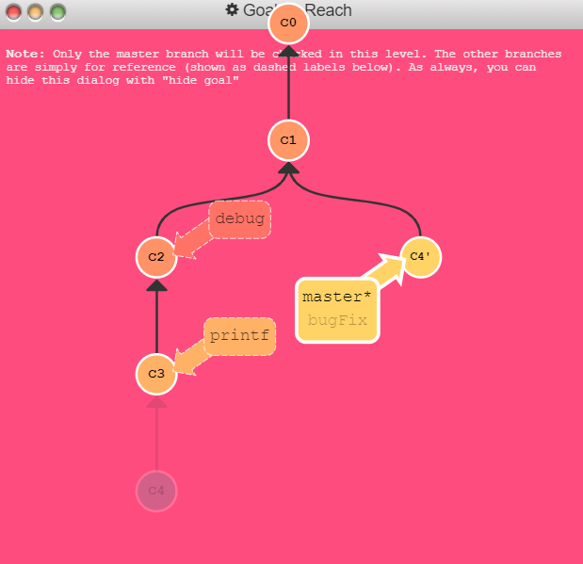

We can do this with just 2 lines of code.
